Appendix I
- Calculating the constitutional core
The constitutional core is the set of provisions that cannot be changed on the basis of the rules specified by the constitution and the preferences of the actors that are required to approve constitutional changes. For example, if revisions require a two-thirds majority in a unicameral legislature, and a minority controlling more than one-third of the seats is in favor of the status quo, then the status quo is in the constitutional core. However, if this minority shrinks to one-fourth of the seats, and three-fourths agree, then the status quo is not part of the constitutional core. The higher the required majorities—say a two-thirds majority instead of a three-fifths majority or a simple majority—the more rigid the constitution. It is also obvious that the higher the required majorities, the more provisions will remain unchangeable, that is, the larger the constitutional core.
My definition of the core differs from the one in the legal literature, which only considers the core as the provisions that the constitution explicitly declares as unamendable (Albert 2015). One significant difference from the legal definition is that because it takes into account the preferences of the different actors, it may identify cases where changes are impossible due to the disagreement of actors (and therefore located inside my definition of the core) but not located inside the legal core.
To understand the location of the constitutional core, consider the preferences of multiple actors in a two dimensional policy space in Figures 1 and 2. The core of this political system is in the center of the political spectrum, because anything located further away from the center (in any direction) will be overruled by the specified qualified majority. Consequently, in a democracy, one should not expect the constitution to include “extreme” positions- that is positions that are objected by an overwhelming majority of the citizens. While this statement is true in general, the precise study of the institutional provisions by which constitutional revision become possible allow a deeper understanding of constitutional rigidity.
The fundamental mechanism of constitutional revisions is a qualified majority of an existing legislative body (parliament) or some specifically elected institution (constituent assembly). In addition to this qualified majority, other institutions may be added, either as complements or as substitutes. If they are complements, the number of constitutional veto players increases. If they are substitutes, the previously defined constitutional veto players are rescinded. Next, I will discuss how the mechanisms of adding or subtracting veto players as well as the effect they have on the constitutional core.

Adding and subtracting veto players
To understand the case of adding a veto player, think of a requirement that specifies a qualified majority of two different institutions. For instance, a lower house and an upper house that are required to agree to an identical text, or a unicameral legislature that is required to approve the same text twice (both before and after an election), or a referendum required for the approval of a text produced by a unicameral legislature. Figure 1 presents the cores C1 and C2 of the two required institutions.
Any outcome located inside the core of either institution also belongs to the bicameral constitutional core. In Figure 1, points X and Y are part of the constitutional core, since any modification of X would fail to command the required majority inside Veto Player One, and any modification of Y would fail to command the required majority inside Veto Player Two. The new constitutional core is not restricted to the combination (union) of the two cores. It also includes the whole area between the two cores. If one connects X and Y with a straight line, the segment XX’ is located inside the core of Veto Player One and consequently cannot be modified. Similarly, the segment YY’ is located inside the core of the Veto Player Two and cannot be modified. The segment X’Y’ also cannot be modified, because each one of the two veto players would pull the points on this segment in opposite directions. Consequently, the whole segment XY is part of the bicameral core, no matter where X and Y are located inside the cores of Veto Players One and Two. In other words, the addition of a second institutional veto player does not simply extend the core to include the core of this second veto player, but it now includes all the area between the two cores (the area A₁A₂B₁B₂ in Figure 1). This is a general statement relating to any additional constraint the constitution may introduce. It never reduces the size of the previously existing core.

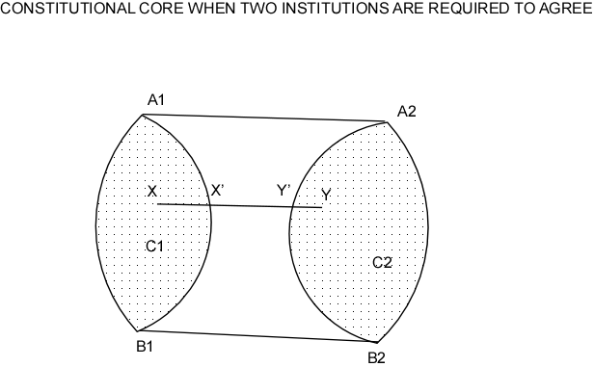
Figure A1

What happens if the constitution adds alternate methods of revision, rather than adding constraints? Figure 2 presents such a situation. Consider that in addition to a three-fourths majority required for approval by a bicameral legislature, represented by chambers A₁A₂A₃ and B₁B₂B₃, the constitution requires either approval by a referendum, represented by Player P, or by an elected president of the Republic, represented by Player Q. On the basis of the previous analysis, the bicameral core would be the whole area A₁A₂A₃B₃B₂B₁. The additional requirement of a referendum would expand the core to the area A₁A₂A₃PB₂B₁, while the alternative route of asking for the approval of the President of the Republic would generate the core A₁A₂A₃QB₂B₁. However, the dotted areas in the picture are not parts of the constitutional core of the country. The points in the dotted areas can be modified by one of the two permissible mechanisms—either the referendum or the president. The constitutional core will be the intersection of the two possible cores, represented by the shaded area in Figure 2.
The two figures demonstrate the logic of constitutional revisions. Their extent depends not only on the institutional provisions but also on the positions of the actors involved. For example, in Figure 1 the constitutional cores of the two chambers could be smaller or overlap, leading to a reduction of the size of the constitutional core. On the other hand, they could be larger and further away from each other, leading to the expansion of the core. Similarly, in Figure 2, one of the two procedures could become easier than the other. For example, if Q is inside the triangle PA₂B₂, then the intersection of the two cores will be identical with the core and requiring approval by Q and P will become irrelevant.

Figure A2

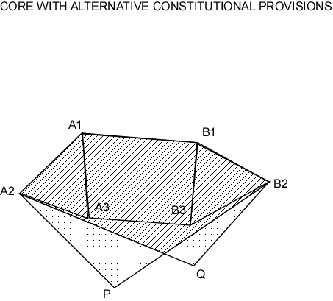
There are two rules that will produce stable effects on constitutional cores. The first is that adding constraints will never reduce a constitutional core, although it may not affect it, depending on the positions of the actors. The second is that adding alternatives will never expand the constitutional core, although again, depending on the position of the actors, it may result in no change. I will use these two rules extensively in the calculation of constitutional cores for the sample of countries in this analysis.

- Small size of the core as a necessary but not sufficient condition for constitutional amendments
Figure A3 presents two different constitutional cores, one large and one small, which is a subset of the large core. This configuration occurs when one removes restrictions from the amendment rule- for instance, when moving from a three-fourths to a three-fifths majority, or if only one chamber of a bicameral legislature is required to approve constitutional revisions (as in the case of Austria). This configuration presents three different potential positions of the status quo status quo. In the first case the status quo (SQ) is located inside the small core (this is, inside both cores), and therefore no constitutional revision is possible. In the second case, the status quo (SQ’) is located outside the small core but inside the large core, and constitutional revisions are possible if the core is small, but impossible if the core is large. In the third case, the status quo (SQ”) is located outside both cores, and while constitutional revisions are possible, the set of possible revisions is larger than in the case with the small constitutional core. All these statements are true, regardless of the position of the status quo in each one of the three areas.
There are several conclusions from this analysis. First, regarding the frequency of amendments: the larger the core, the fewer constitutional amendments are possible (SQ’ can be modified with a small core, but not with a large one).
Second, the importance of the potential amendments is correlated with the size of the core. In Figure A3 SQ” has a large distance from the small core (but not from the large one). Consequently, a large constitutional revision is possible if the core is small. Figure A3 also demonstrates that this change is not possible with a large core.

Figure A3
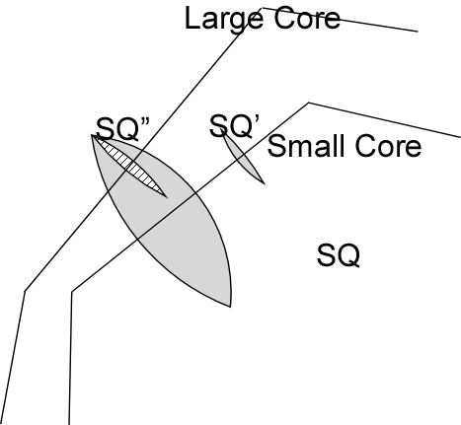
Note: Large Core produces smaller winset, no matter where SQ is
Third, the arguments above produce necessary but not sufficient conditions for constitutional amendments. Constitutional amendments are impossible when the status quo is inside the core, but just possible (though not necessary) in cases where the status quo is outside the core. This has implications about the variance of the relationship between constitutional rigidity and the frequency of amendments: lower constitutional rigidity will present higher variance, because more constitutional amendments become possible (but again, not necessary). Consequently, my analysis predicts not only a negative relationship between constitutional rigidity and amendment frequency but a heteroskedastic one too.
Appendix IV
Regression Results for Frequency of All Amendments
 |  | Coefficient | Standard Error | P-Value | 95% Confidence Interval
Freq. of All Amendments
Null Model
 | Constant | 0.277*** | 0.027 | 0.000 | 0.224-0.330
Mean-Only Model
 | VP Rigid. | -0.281** | 0.095 | 0.003 | -0.468- -0.095
 | Constant | 0.526*** | 0.088 | 0.000 | 0.353-0.698
Heteroskedastic Model

 | VP Rigid. | -0.299** | 0.091 | 0.001 | -0.477- -0.120
 | Constant | 0.542*** | 0.089 | 0.000 | 0.366-0.717
Exp. Model of the Variance
 | VP Rigid. | -0.723 | 0.601 | 0.229 | -1.902-0.455
 | Constant | -2.145*** | 0.551 | 0.00 | -3.226- -1.064
* p<0.05, ** p<0.01, *** p<0.001

Frequency of Major and Fundamental Amendments

 |  | Coefficient | Standard Error | P-Value | 95% Confidence Interval
Freq. of Major and Fund. Amendments
Null Model
 | Constant | 0.128*** | 0.017 | 0.000 | 0.094-0.162
Mean-Only Model
 | VP Rigid. | -0.148* | 0.064 | 0.016 | -0.273- -0.029
 | Constant | 0.261*** | 0.058 | 0.000 | 0.148-0.374
Heteroskedastic Model

 | VP Rigid. | -0.163** | 0.052 | 0.002 | -0.265- -0.062
 | Constant | 0.274*** | 0.057 | 0.000 | 0.163-0.384
Exp. Model of the Variance
 | VP Rigid. | -2.114*** | 0.621 | 0.001 | -3.332- -0.896
 | Constant | -1.856*** | 0.569 | 0.001 | -2.97- -0.741
* p<0.05, ** p<0.01, *** p<0.001

Frequency of Fundamental Amendments

 |  | Coefficient | Standard Error | P-Value | 95% Confidence Interval
Freq. of Fundamental Amendments

Null Model
 | Constant | 0.046*** | 0.012 | 0.000 | 0.023-0.697
Mean-Only Model
 | VP Rigid. | -0.078 | 0.043 | 0.071 | -0.162-0.007
 | Constant | 0.115** | 0.040 | 0.004 | 0.037-0.193
Heteroskedastic Model

 | VP Rigid. | -0.061** | 0.022 | 0.006 | -0.105- -0.017
 | Constant | 0.098*** | 0.029 | 0.001 | 0.041-0.153
Exp. Model of the Variance
 | VP Rigid. | -5.392*** | 0.540 | 0.000 | -6.460- -4.334
 | Constant | -0.249 | 0.499 | 0.618 | -1.226- 0.729
* p<0.05, ** p<0.01, *** p<0.001

