Global Feminisms Project Educational Toolkit

Art & Feminism Lesson Plan

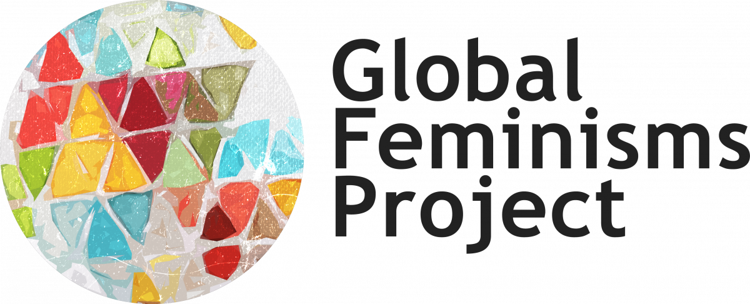

Driving Question  - Is there a Feminist Art?  Supporting Questions  - What are the connections between art and feminism?  - How does art informe people’s lives and experiences?  - How does art reflect social, historical and cultural issues?  - What are the differences in artistic practice depending on different geographical contexts?  - What is the role of the artist in society?  - What is the role of a feminist artist? | Enduring Understandings  - Connections between art and feminism.  - Differences in artistic practices and expressions depending on socio-historical and geographical contexts.  - Roles and practices of artists and of feminist artists in particular.  - Connections between art and socio-historical and cultural issues.  - Connections between feminist art and women’s lives and experiences.
Overview  In this lesson students begin by discussing and reflecting on various definitions of art and artists’ roles to subsequently compare them with definitions of feminist art, along with the role and practice of feminist artists. Students are encouraged to reflect on the connections between art and social, historical and cultural issues, as well as differences across countries and art forms. From the work done in the two activities, in the final assignment students are asked to create their own feminist art manifesto that expresses their understandings and characterization of feminist art. | Learning Objectives  - Understand different definitions of art and artistic practices  - Reflect on different understandings of the artist’s role  - Understand the connections between art and social, historical and cultural issues  - Reflect on the connection between art and feminism  - Discuss different understandings and definitions of feminist art  - Reflect on different understandings of feminist artists’ roles and practice  - Reflect on the connections between feminist art and women’s lives and experiences  - Discuss the differences and similarities of feminist art and practice in different countries and socio-historical contexts  - Be able to expose main ideas and arguments of feminist art.  - Understand main characteristics and elements of feminist manifestos  - Build hands-on skills by producing a creative project  - Understand and apply the basic principles of presenting and exposing an argument
Key Concepts
- Art
- Feminist Art
- History and Culture
- Creative Work
- Manifestos
Teacher Preparation and Instructional Resources
In preparation for the class, the instructor will divide students into four groups and each group will read excerpts from one interview (Brazil, India, United States and Russia). Students from each group will individually read the interviews outside of class.
Additionally, in preparation for the class, the instructor can ask the students to read the written introductions to the different countries (available on the Global Feminisms Project website and linked below), to take a look at the interactive timelines, and/or listen to the podcasts discussing the interviews (see links below and on the Global Feminisms website).
Activity 1 aims to introduce students to different definitions of art and the role of artists by comparing quotationss from artists, writers, art critics and scholars with excerpts from interviews with feminist artists, scholars and art critics from the Global Feminisms Project. This activity builds the base for the second activity, which is focused on definitions and practices of feminist art. The activity is divided in two parts; in both parts, the students alternate group work with whole class discussion and follow up.
Activity 2 builds on the work done in Activity 1, by presenting definitions and understandings of feminist art and the role and pratice of feminist artists. In the activity, students begin by reading and discussing quotations from feminist artists, scholars and writers and then work with new interview excerpts from the interview they have already worked with in Activity 1. Throughout the activity, students are encouraged to consider the relation between art and feminism and the importance of feminist art and feminist artists for the women’s movement, as well as how feminist art speaks of women’s lives and experiences and social and political issues as a whole. This activity builds the base for the work that will be done in the assignment.

The final Assignment builds on the work done in Activity 1 and 2 by asking the students to create a feminist art manifesto. Students will be working in the same groups they formed for Activity 1 and 2. The manifesto can take different forms: it can be done as a text, audio, video or collage, among other forms of creative work. An introduction to feminist manifestos can be provided in class in preparation for the assignment, using the resources provided in this packet. After each group has produced their manifesto, they will be presenting it to the class and explaining their process as well as their definition of feminist art and how it is reflected in their manifesto.

- Activity 1 : Print or electronically distribute copies of Handout 2 among students in preparation for the class. In class, print or electronically distribute copies of Handout 1 and Reading Guide 1 among students. They will be working in four groups; however, it is recommended that each student have access to all the materials. If the class is held virtually, the group work part of the activity can be done in breakout rooms.
- Activity 2: Print or electronically distribute copies of Handout 4 among students in preparation for the class. In class, print or electronically distribute copies of Handout 3 and Reading Guide 2 among students. As in Activity 1, students will be working in four groups (these groups are the same as those in Activity 1). However, it is recommended that each student have access to all the material. If the class is held virtually, the group work part of the activity can be done in breakout rooms.
- Assessment: Print or electronically distribute copies of Handout 6 among students. The assignment will be presented in class, and it is recommended to provide an introduction to manifestos and feminist manifestos using the overview and resources available in Handout 5. Handout 5 is intended for instructor use only; however, the instructor may want to share examples of feminist art manifestos with students. If so, the instructor can use the links provided in Handout 5. The assignment can be completed out of class and after it is finished, it asks the students to share and present their final products with the rest of the class and to summarize their process and definitions of feminist art.

Duration
- Estimated as ~ 3 class periods (Activity One + Activity Two + Assessment introduction ~ 130/150 minutes)

Lesson Handouts/Materials

Activity 1 | Activity 2 | Assessment
- Handout 1 | - Handout 3 | - Handout 5
- Handout 2 | - Handout 4 | > Handout 6
> Reading Guide 1 | > Reading Guide 2

Proposed Lesson Sequence

- Opening
Students have already read the assigned interview’s excerpts and may have also read the country’s written description as well as looked at the country’s statistics, maps, interactive timelines and podcasts. You can begin the lesson by telling them that, as they may have guessed from the excerpts, the fragments of the interview that they read belong to activist women who are either artists or writers themselves, or art historians and curators. You can also tell them that the goal of this lesson is to discuss definitions of art, artists’ roles and practices and to compare them with understandings and definitions of feminist art and practice. The whole lesson is organized around art and feminism, and its connections with history and culture, as well with the women’s movement and women’s lives and experiences in different countries and contexts. Before starting with the first activity, you may also briefly reintroduce the interviews, drawing from the materials that help to contextualize them available on the Global Feminisms Project website (see the list below).

- Guided Inquiry
Before getting started with the first activity, you may tell the students that this lesson is organized to start by discussing definitions of art and artists’ roles and practices, to later consider definitions of feminist art and feminist artists’ roles and practices. Furthermore.the work that they do in the two activities will be the base for the work they will be doing in the assignment. In this sense, the lesson presents a scaffolding of the different elements that define art and artistic practices in various historical, cultural and geographical contexts. As such, whole class follow ups are important to encourage students to make connections among the different materials, definitions and ideas that they are working on. It is particularly important to encourage students to reflect on the characteristics of feminist art and its connections to society and culture and women’s lives and experiences at the end of Activity 2. The notes that they can take from that discussion can be very helpful for the work that they will be doing during the assignment. If needed, you can draw some ideas for further contextualizing art and artistic practices from the list of additional resources for art lesson plans and feminist art provided below (Additional Resources for Art Lesson Plans and Feminist Art).

- Independent Practice
Both activities are designed for students to work with the sources independently in four different groups. At the end of each segment, there are whole class follow ups in which the students will synthesize their findings and share them with the other groups. Whole class follow ups are important since each group is working with a different country and they are asked to consider the differences and similarities between geographical and socio-historical contexts. It is also important that each group takes notes of their answers and of the whole class discussions, as the notes will be helpful for working on the final assignment. If the class is held virtually, it is recommended to pop up in the breakout rooms to provide the chance for students to ask questions if they have them.

- Assessment
Before the assessment, it is recommended to provide an introduction to manifestos and feminist manifestos in particular, by using the information and resources from Handout 5. It is also recommended to give some time for students to ask questions about the assignment before they start creating their feminist art manifesto. Depending on the form they choose for their manifesto, students will develop hands-on skills by working collaboratively in producing a creative project. Furthermore, during the assignment, students not only will be organizing main ideas and arguments of feminist art and translating them into a creative project, but will be understanding and applying the basic principles of developing and presenting an argument.

- Sharing and Reflection
It is recommended to conduct a whole class follow up once the assignment is completed by the students. Students will be sharing and presenting their feminist art manifestos and discussing them with the rest of the class. In this presentation, students will be asked to explain their process and to describe their definitions of feminist art and how it is reflected on their manifesto. The instructor can also encourage them to reflect on the genre of the manifesto and the writing, creative and hands-on skills that they had to apply in their creation. Specifically, the instructor can ask the students what language they had to use for creating their manifesto and how they organized the argument they wanted to present in light of the potential audience that the manifesto would have (manifestos are produced using an emotional and creative language, are intended to provoke impact, including radical social change, and to be transformative). In this sense, the instructor can go through the set of bullet points presented when introducing manifestos (Handout 5) to the students and ask them to what extent they see these elements reflected on their own manifestos.

- Additional resources available on the Global Feminisms Project website

- Brazil Site of the Global Feminisms Project
- US Site of the Global Feminisms Project
- Russia Site of the Global Feminisms Project
- India Site of the Global Feminisms Project

- Additional Resources for Art Lesson Plans and Feminist Art

- University of Michigan Museum of Art (UMMA)
- Exchange: Writing + Art Enrichment Activities (UMMA)
- The Art Story: Visual Art Movements, Artists, Ideas, and Definitions
- Feminist Art Movement Overview | TheArtStory
- What Is Art? Considering and Creating Artistic Works
- Lesson Plans - The Met Museum
- Art & Language Arts Curriculum (Education at the Getty)

- References and Additional Resources for Manifestos and Feminist Manifestos

Weiss, Penny A (ed). Feminist Manifestos: A Global Documentary Reader. New York: NYU Press, 2018
Fahs,Breanne. Burn It Down! Feminist Manifestos for the Revolution. New York: Verso, 2020.
Fahs, Breanne. “Writing with blood: The transformative pedagogy of teaching students to write manifestos”. Radical Teacher 115, 2019, 33-38.
Hannah, Julian. “Manifestos: A Manifesto.” The Atlantic, 24 June 2014, https://www-theatlantic-com/entertainment/archive/2014/06/manifestos-a-manifesto-the-10-things-all-manifestos-need/372135/
Yanoshvsky, Galia. “Three Decades of Writing on Manifesto: The Making of a Genre.” Poetics Today 30, no. 2, 2009,257-286.

- Alternative interviews that can be used for the lesson plan

Below there is a list of alternative interviews that can be used for the lesson plan. Each of them was conducted with activist women artists, art critics and scholars who reflect on feminist art pratices and forms .

India
Urvashi Butalia / Mahasweta Devi / Lata Pratibha Madhukar

Poland
Inga Iwasiów

China
Wei Tingting / Ai Xiaoming

Germany
Katharina Oguntoye / Marion Schmidt

Brazil
Laura Castro / Giordana Moreira

