Global Feminisms Project Educational Toolkit

Representing Life Stories Using Digital Tools Lesson Plan

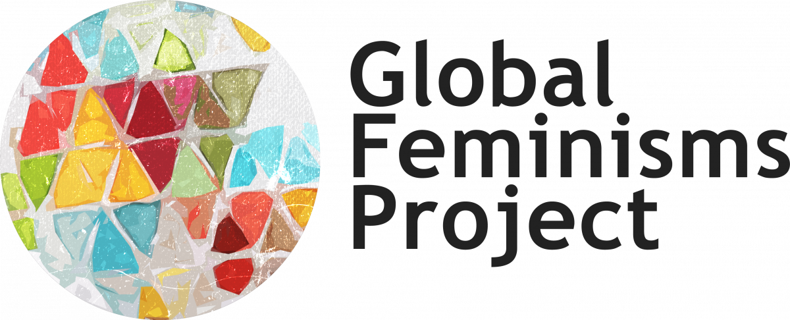

Driving Question  - How can activist women’s lives be told by using digital tools?  Supporting Questions  - What are the intersections between micro and macro histories (that is, between the individual life history and larger social histories)?  - How does history inform people’s lives?  - What are the differences between a story represented in a written text and in an interactive visualization?  - How is information presented, organized and shared in a text and in a sequence of life events? | Enduring Understandings  - Intersections between history and individuals’ lives.  - Articulations of personal and political identities.  - Presentation, organization and sharing of life events in a timeline  - Developing hands-on skills that allows students to create digital interactive timelines.
Overview  In this lesson, students will analyze activist women’s interviews to identify life events that shaped that person’s identity in order to build a timeline of the person’s life. Students will discuss these events in light of the historical events from the country of origin of the interviewee, as well as the history of women’s rights in that country. In the final assignment, students will use the timeline that they have created to build a digital interactive timeline using the open access tool Timeline JS. | Learning Objectives  - Use students’ personal past experiences to build their understanding of narrating life stories  - Analyze primary sources to create a timeline of events of one person’s life  - Consider the overlap between macro and micro histories  - Discuss how historical events inform people’s lives  - Develop research skills by looking into visual materials that can be used for the timeline  - Reflect on the differences between the written text and an interactive visualization  - Reflect on the way in which information is presented, organized and shared
Key Concepts
- Storytelling
- Life Stories
- Digital Methods
- History
- Timelines
Teacher Preparation and Instructional Resources
In preparation for the class, the instructor will divide students into four groups and each group will read one complete interview (Shtyleva -Russia-; Gao -China-; Núñez -Nicaragua-; Lee Boggs -US-). Students from each group will individually read the interviews outside of class.
Additionally, in preparation for the class, the instructor can ask the students to read the written introductions to the different countries (available on the Global Feminisms website and linked below) and/or listen to the podcasts discussing the interviews (see links below and on the Global Feminisms website). The instructor may not choose to ask the students to review the interactive timelines for each country, as they will be used and analyzed in Activity 2.
Activity 1 aims to introduce students to the process of reflection on narrating life stories and creation of a timeline of relevant life events that shaped one person’s life. The activity starts by drawing from students’ own reflections on their lives and significant events to later consider one activist woman’s life through the analysis of an interview from the Global Feminisms Project. This activity creates the base material for the comparative work that will be done in Activity Two and the applied work that will be completed in the assignment.
Activity 2 builds on the work done in Activity 1 of identifying relevant life events in a person’s narrative. In this activity, students will look at the timeline for each of the countries presented in the interviews available on the Global Feminisms Project website. By discussing the overlaps between the history of the country and women's rights, this activity seeks to ask students to consider the relationship between macro and micro histories and how history informs people’s lives. Students will end the activity by considering how the overlapping events can be integrated into the draft of the timeline that they created in activity 1. This is the material that they will be working with to create their own interactive timelines during the assignment.
The final Assignment asks students to create their own interactive timelines based on the draft that they have produced during Activity 1 and 2. They will be using the open access tool Timeline JS. Before students start with the hands-on work, the instructor will introduce Timeline JS and the process of creating a timeline using the training presentation that is provided in this packet, titled “How to create a Timeline JS”. The presentation guides students throughout the process of creating their timeline, but it is advisable that the instructor presents it in class before the students begin with the work, in case there are questions. Once students create their timelines, they will be asked to reflect on the singularities of the visualization that they have just created and how the narrative differs from the one presented in the interview. Students will develop hands-on skills and consider ways to transform narratives into a set of sequenced events that combine people’s individual lives with historical events. Students will be sharing their timelines and reflections with the entire class once the assignment is completed.

- Activity 1 : Print or electronically distribute copies of Handout 1 among students in preparation for the class. In class, print or electronically distribute copies of Reading Guide 1 among students. They will be working in four groups; however, it is recommended that each student have access to both materials. If the class is held virtually, the group work part of the activity can be done in breakout rooms. To model the second part of the activity, you will be using the Model Interview and Handout 2. These two materials are instructor only and do not need to be distributed among students.
- Activity 2: Print or electronically distribute copies of Reading Guide 2 among students. As in activity 1, students will be working in four groups (these groups are the same as those in Activity 1). However, it is recommended that each student have access to the material. If you choose to distribute printed copies of Reading guide 2, you will need to share the links of the four country’s timelines with the students (see links below). If the class is held virtually, the group work part of the activity can be done in breakout rooms.
- Assessment: Print or electronically distribute copies of Handout 3 among students. The assignment will be presented in class, together with the How to create a Timeline JS presentation. This presentation will also be shared with the students as it will help them to work on creating the digital interactive timelines. The assignment can be done out of class and after completed, it asks the students to share their final products with the rest of the class and to reflect on a series of questions.

Duration
- Estimated as 3+ class periods (Activity One + Activity Two + Assessment introduction and Timeline JS training ~ 150 minutes)
Lesson Handouts/Materials

Activity 1 | Activity 2 | Assessment
- Handout 1 | - Reading Guide 2 | - Handout 3
- Reading Guide 1 | - Timeline on China (Gao Xiaoxian) | > How to create a Timeline JS
> Model interview | > Timeline on Russia (Liubov’ Vasil’evna Shtyleva)
> Handout 2 (instructor only) | > Timeline on the United States (Grace Lee Boggs)
 | > Timeline on Nicaragua (Vilma Núñez)

Proposed Lesson Sequence

- Opening
Students have already read the assigned interview and may have also read the country’s written description as well as looked at the country’s statistics and maps. You can begin the lesson by telling them that the interview that they have read, presents an individual’s story in the form of a text, and as they have gone through it, they may have read about significant events that shaped that person’s life. Their work throughout the two activities will be transforming this text into a sequence of life events to end up having a timeline that will be transformed into an interactive digital visualization.
Before starting with the first activity, you may also briefly reintroduce the interviews, drawing from the materials that help to contextualize them available on the Global Feminisms website (see the list below).

- Guided Inquiry
Before getting started with the first activity, you may tell the students that in the first part, they will be asked to consider their personal past experiences and how they have shaped their identities. You may want to model some of this reflection by sharing with the students one or two examples from your life. Once they complete the first part of the activity and they do the whole class follow up, you will model the second part of the activity by drawing from the resources included in this packet. Similarly, in the second activity, you may also want to briefly present the country’s timelines to the students and model the work that they will be doing by drawing from the model interview and the timeline on India (see link below). This can help the students to identify the overlaps between history and individual’s stories. Finally, before they start with the hands-on work for the assignment, you will present the process of creating an interactive digital timeline by using the step by step guide offered in this packet.

- Independent Practice
Both activities are aimed for students to work with the sources independently in four different groups. At the end of each segment, there are whole class follow ups in which the students will synthesize their findings and share them with the rest of the groups. Whole class follow ups are important since at the end of the lesson plan, the students will be asked to reflect on the work that they have done transforming a written text into a set of sequenced events and the intersections between history and individual’s life stories. If the class is held virtually, it is recommended to pop up in the breakout rooms to provide the chance for students to ask questions if they have them.

- Assessment
During the assignment, students will develop hands-on skills by creating interactive timelines using the open access digital tool Timeline JS. Furthermore, students will be developing research skills by looking into media that can be used for their timelines, and consider good practices for citing sources. Finally, students will be reflecting on the way in which information is presented, organized and shared and the differences between a written text and an interactive visualization.

- Sharing and Reflection
It is recommended to conduct a whole class follow up once the assignment is completed by the students. Students will be sharing their interactive digital timelines and discussing them with the rest of the class. Furthermore, there are a set of questions included at the end of the assignment that seek to create enduring understandings of the work done among students. In this sense, the instructor can encourage students to reflect on the differences between the visualization that they created and the interview that they read. Specifically, they can consider how the information is presented differently and how the intersection between history and individuals’ lives is presented in the interactive timeline.

- Additional resources available on the Global Feminisms Project website

China Site of the Global Feminisms Project
Russia Site of the Global Feminisms Project
Nicaragua Site of the Global Feminisms Project
US Site of the Global Feminisms Project

- Alternative interviews that can be used for the lesson plan

Below there is a list of alternative interviews that can be used for the lesson plan. Each of them offers a good description of the woman’s life events.

India
Neera Desai

Poland
Barbara Labuda

United States
Rabab Abdulhadi

Nicaragua
Diane Martinez

Germany
Heidi Meinzolt-Depner

Brazil
Maria Teles

Nigeria
Yemisi Ransome-Kuti

